**Project Title:** Data Strategy: Methodology and Usecase Implementation for Organizations or its Business Divisions

**Project Summary :** In today’s data-driven landscape, organizations must proactively manage their data assets to remain competitive. A well-defined data strategy serves as a roadmap for achieving this goal. There is a need to have a data strategy that will help organisations enhance how it stores, analyses, and utilises the massive volume of data for efficient operations and improved decision-making.

**Novelty of the project:** The project focuses on the real-life problem of a huge multinational and its business division. The report delves into the methodology of how to implement a data strategy and a use case implementation with the principles of strategy. The below diagram also depicts the three key pillars of implementing the data strategy.

**Design Diagram:** the diagram below illustrates the overarching design methodology that is intended to be followed to develop the data strategy and what key objectives will be fulfilled.

The data and analytics strategy of Unilever will feed into the strategy for the specific business group (Beauty and Wellbeing). Both the organization strategy and the business group strategy should be aligned and work hand in hand. The business groups strategy would then fuel three key areas:

1. Awareness and adoption of prioritised Data tools such that there is a single source of truth across.

2. A major division of FMCG (Beauty and Wellbeing) specific use cases should be powered with right data end to end – this will include data consumption, storage and processing as well. One key use case for example is a mobile application for beauty tech.

3. Beauty and Wellbeing Data initiatives that would include mostly buying/resourcing new data sources (internal and external) for consumption and creating new insights.

Results:

Data Dictionary was created , a snippet of which is shown below. This is for easy comprehension and traceability of data initiatives in the future.

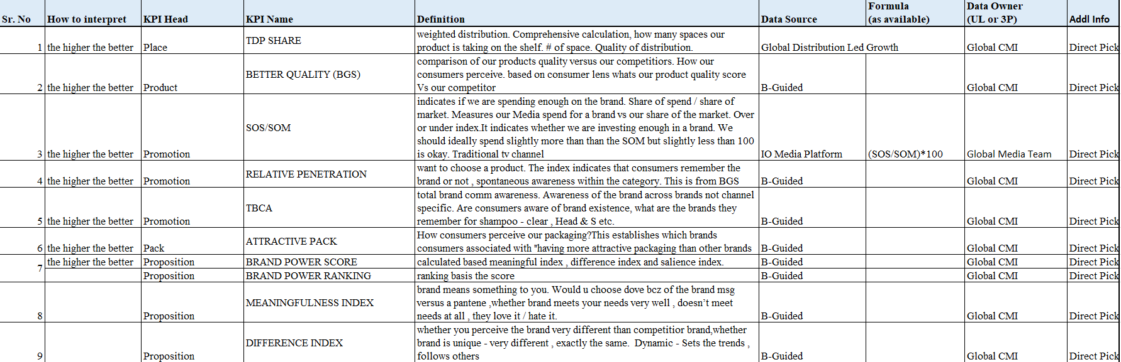

Snippets below are from the use case implementation with brief description at the bottom of the image.

Figure 1: Executive summary view showing the 6P KPIs across a trend with a visual depiction.

Figure 2: Executive Summary view showing the price KPIs, digital transformation KPIs and financial metrics along with trended charts and Moving Averages (MAT)

Figure 3: Showing Value and Volume trends across time for India Wash and Care

Figure 4: Showing value and volume changes on a trend for Unilever and its top competitors and brands

**Data Strategy Alignment:** Data Strategy alignment in terms of below checkmarks was achieved:

* Improving Data Discoverability and Accessibility
* Enhancing data quality and reducing silos
* Optimizing resource utilization
* Ensuring data security and compliance